The __________________________ of a random variable is the long-run average value of repetitions of an experiment. In other words, it’s a quantity equal to the average result of an experiment after a large number of trials (Law of Large Numbers).

Expected value is the ______________________________ of all possible values.

Each possible random value (x) is multiplied by its probability P(x) of occurring, and the resulting products are summed (added) to produce the expected value.

E(x) = x1 🞄 P(x1) + x2 🞄 P(x2) + x3 🞄 P(x3) + … + xn 🞄 P(xn)

**Multiply each value *x* and its probability *P*(*x*) and add them all up.**

**For example**, if one fair die is rolled, the expected value of the number rolled is 3.5. This is a correct interpretation even though it is impossible to roll a 3.5 on a 6-sided die. This sort of thing often occurs with expected values because it’s a weighted average. According to the Law of Large Numbers, 3.5 is the average of all possible values rolled by the die.

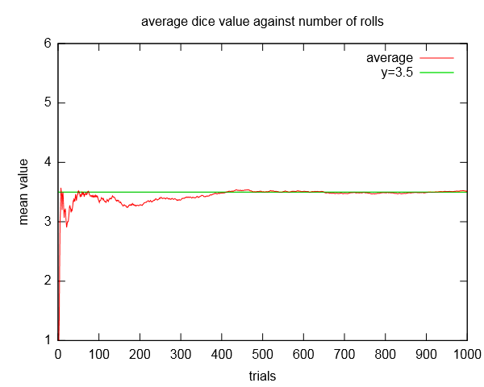

|  |  |
| --- | --- |
| **x** | **P(x)** |
|  |  |
|  |  |
|  |  |
|  |  |
|  |  |
|  |  |

E(x) = ______________________________________________________________________

**EXAMPLE:** If 5 apples in a barrel of 25 apples are rotten, what is the expected number of rotten apples in a random sample of 2 apples?

“expected number” means to find “expected value” formula: _________________________

* 5 out of 25 apples are rotten. What’s probability of getting a rotten? *P*(rotten) = __________
* In a sample of 2 apples, the expected number of rotten is *E*(rotten) = _________________

**EXAMPLE:** From a group of 5 men and 6 women, a delegation of 4 is chosen at random. What is the expected number of men in the delegation? Round to the nearest hundredth.

“expected number” means to find “expected value” formula: _________________________

* 5 out of 11 in the group are men. What’s probability of men? *P*(men) = __________
* A delegation of 4 is chosen, the expected number of men is *E*(men) = ________________

**EXAMPLE:** A contractor is considering a sale that promises a profit of $37,000 with a probability of 0.7 or a loss of $13,000 (due to bad weather, strikes, and such) with a probability of 0.3. What is the expected profit?

“expected profit” means to find “expected value” formula:________________________

This information may be easier to manage in a table.

|  |  |  |  |
| --- | --- | --- | --- |
|  | **profit** | **loss** | **Total expected profit ($)**  **(see below)** |
| **amount ($), or *x*** |  |  |
| **probability, or *P*(*x*)** |  |  |
| **expected profit, or $$E\left(x\right)=x∙P(x)$$** |  |  |  |

**EXAMPLE:** Experience shows that a ski lodge will be full (199 guests) if there is a heavy snow fall in December, while only partially full (92 guests) with a light snow fall. What is the expected number of guests if the probability for a heavy snow fall is 0.40. Assume that heavy snowfall and light snowfall are the only two possibilities.

“expected number of guests” means to find “expected value” formula:_______________________

This information may be easier to manage in a table.

|  |  |  |  |
| --- | --- | --- | --- |
|  | **Full lodge (heavy snow)** | **Partially full lodge (light snow)** | **Total expected number of guests**  **(see below)** |
| **number of guests or *x*** |  |  |
| **probability, or *P*(*x*)** |  |  |
| **expected number of guests, or $$E\left(x\right)=x∙P(x)$$** |  |  |  |

**EXAMPLE:** A certain game consists of rolling a single fair die and pays off as follows:

$10 for a 6, $8 for a 5, $2 for a 4, and no payoff otherwise. Find the expected winnings of this game.

“expected winnings” means to find “expected value” formula:_______________________

This information may be easier to manage in a table.

|  |  |  |  |  |  |
| --- | --- | --- | --- | --- | --- |
| **roll on the die** | **6** | **5** | **4** | **“otherwise”**  **(roll 3 or 2 or 1)** | **Total Expected winnings ($)**  **(see below)** |
| **winnings ($) on that roll of the die, or *x*** | **10** | **8** | **2** | **0** |
| **probability or *P*(*x*)** | $$\frac{___}{___}$$ | $$\frac{___}{___}$$ | $$\frac{___}{___}$$ | $$\frac{___}{___}$$ |
| **Expected winning, or $$E\left(x\right)=x∙P(x)$$** |  |  |  |  |  |

**EXAMPLE:** Find the expected value of the random variable. Round to the nearest thousandth.

The random variable *X* is the number of siblings of a student selected at random from a particular secondary school. Its probability distribution is given in the table.

|  |  |  |  |  |  |  |
| --- | --- | --- | --- | --- | --- | --- |
| $$x$$ | 0 | 1 | 2 | 3 | 4 | 5 |
| $$P(X = x)$$ | $$\frac{13}{48}$$ | $$\frac{1}{3}$$ | $$\frac{5}{24}$$ | $$\frac{5}{48}$$ | $$\frac{1}{24}$$ | $$\frac{1}{24}$$ |

Remember for **expected value**, just multiply the value *x* times its probability *P*(*X* = *x*).

Let’s add more info to the given table:

|  |  |  |  |  |  |  |  |
| --- | --- | --- | --- | --- | --- | --- | --- |
| **Number of siblings, $x$** | 0 | 1 | 2 | 3 | 4 | 5 | **Total overall expected value (see below)** |
| **Probability, $P(X = x)$** | $$\frac{13}{48}$$ | $$\frac{1}{3}$$ | $$\frac{5}{24}$$ | $$\frac{5}{48}$$ | $$\frac{1}{24}$$ | $$\frac{1}{24}$$ |
| **Expected number of siblings, $E(x)$ $$x∙P(X=x)$$** |  |  |  |  |  |  |  |

**EXAMPLE:** A study at an amusement park found that, of 10,000 families at the park, 1650 had brought one child, 2190 had brought two children, 2210 had brought three children, 1520 had brought four children, 950 had brought five children, 1050 had brought six children, and 430 had not brought any children. Find the expected number of children per family at the amusement park.

Let’s work with this information in a table:

|  |  |  |  |  |  |  |  |  |
| --- | --- | --- | --- | --- | --- | --- | --- | --- |
| **Number of children, $x$** | **0** | **1** | **2** | **3** | **4** | **5** | **6** | **Total overall expected number of children**  (round to tenth) |
| **Probability, or $P(X = x)$** | $$\frac{430}{10000}$$ | $$\frac{1650}{10000}$$ | $$\frac{2190}{10000}$$ | $$\frac{2210}{10000}$$ | $$\frac{1520}{10000}$$ | $$\frac{950}{10000}$$ | $$\frac{1050}{10000}$$ |
| **Expected number of children, or $E(x)$ $$x∙P(X=x)$$** |  |  |  |  |  |  |  |  |